Conceptual Framework

Midterm Draft

**Team: Access-Ability Innovators**

El Shammas, Lama Rita

Li, Jiaying

Truong, Tam K

Srinivasan, Siddharth

**CS-6795: Introduction to Cognitive Science**

**Dr. Michael Helms**

1. **A brief description of the domain you are studying**

We focused on developing a computational model to aid in the design thinking process for producing accessible materials for disabled students, specifically focusing on blind students. Blindness poses unique obstacles to the traditional design process, as approximately 30% of the neurons in the human cortex are dedicated to visual processing. Consequently, designers need help conceptualizing and producing materials that effectively convey information without relying on visual cues. We chose to aid designers in creating material for blind students as they heavily focus on vision impairment. Our interviews revealed that there are many factors that play an important role in the design considerations. By leveraging computational modeling techniques, we aim to bridge this gap and support designers in creating inclusive and accessible resources for blind students. The computational model will incorporate various cognition, perception, and human-computer interaction elements to simulate and assist in the design thinking process. Our research will focus on helping the designers think about ways to combat the problems faced while creating these accessible materials, such as image reading and mathematical equations. The model will facilitate the exploration of alternative modalities and representations to convey mathematical concepts effectively without visual cues. Moreover, It will explore techniques for converting visual information, such as diagrams, graphs, and charts, into accessible formats that can be effectively conveyed through touch, sound, or speech. It includes developing methods for describing visual elements and their relationships in a structured and meaningful way, allowing blind students to access and comprehend information presented in visual form.

2. **A conceptual schema in the form of a UML or E/R diagram**

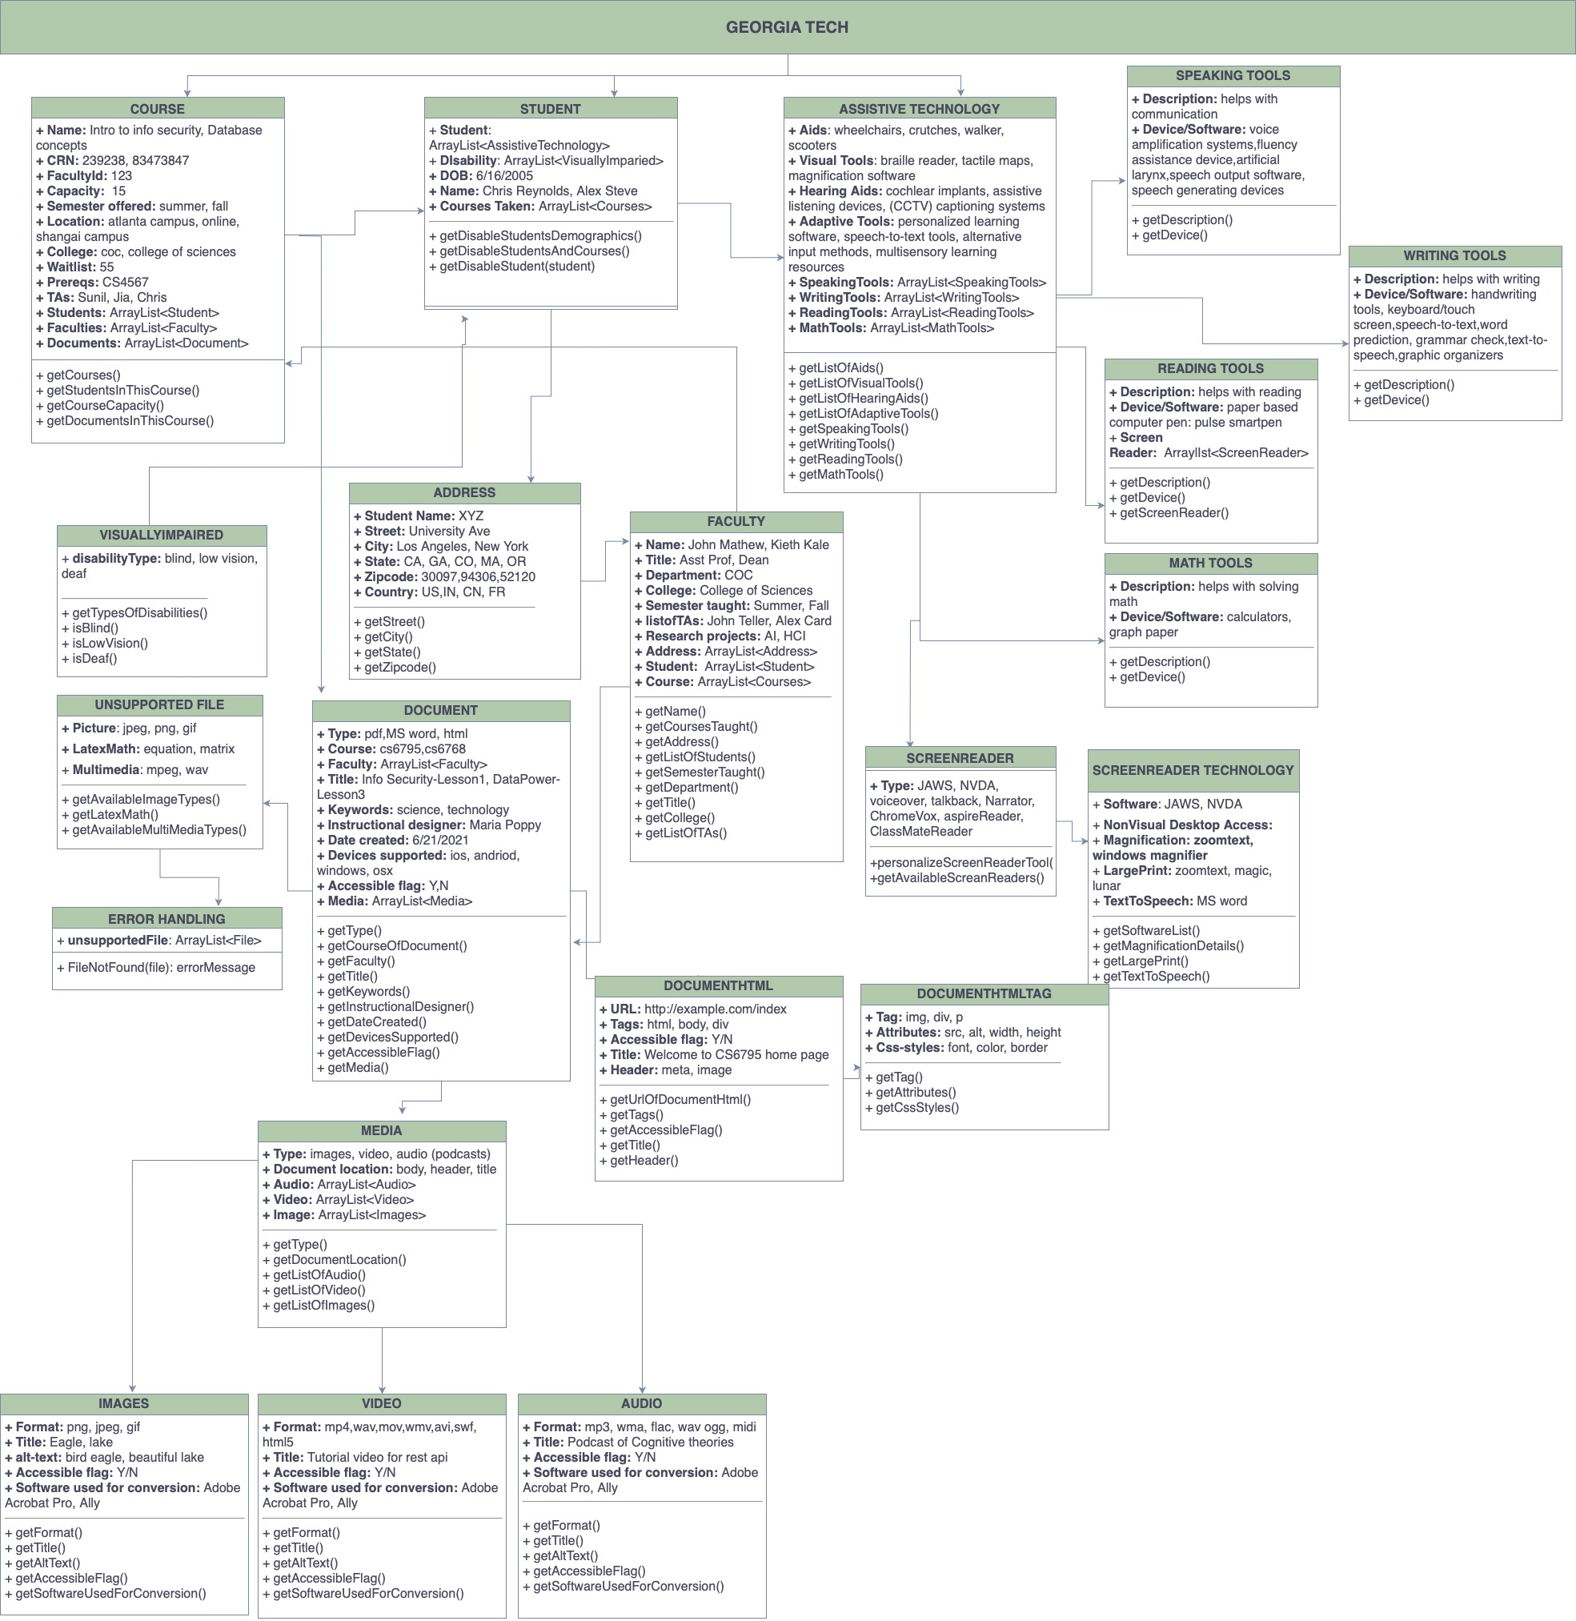

3. **A table supporting each schema decision with interview data**

| **Schema Decision** | **Supporting Interview Data** |
| --- | --- |
| Disability type: Blind, low vision | “I have been doing a lot of the materials for our students with vision impairments and changing materials into an accessible format is pretty important because they need to be able to read it with a screen reader” |
| Aids: wheelchairs, crutches, walker,  scooters | “I was also approached by uh disability services and asked to be on standby for students who had mobility needs like providing wheelchairs and crutches around campus” |
| Picture: jpeg, png, gif | “The first challenge is that some of these professors are saving their materials as a picture. And when you save materials as a picture, even though it might be a PDF file, the materials as a picture within the PDF file screen reading technology only picks it up as a blank” |
| LatexMath:equation, matrix | “The second challenge is math because unless you write math in a specific format. Screen reading technology doesn't pick it up. When I say a particular format, a couple of math editors can create the math and the latex-type technology or software that can generate math in a format that the screen readers can read.” |
| Visual tools: braille reader, tactile maps, magnification software, | “If our students are Braille readers, we can give material in Braille”  “For one student, we actually got him his flow chart for the the summer in a tactile graphic”  “We also use a magnification device for some students who want to take a test on paper but can't read if it's a 12-point font” |
| Adaptive Tools: personalized learning software, speech-to-text tools, alternative _ input methods, multisensory learning  resources | “For individuals who have difficulty typing or navigating websites with complex interfaces, voice recognition, and dictation software can be valuable.” |
| Hearing aids: cochlear implants, assistive listening devices, captioning systems | “We have a desk student who uses Bluetooth technology to connect an amplification device to his hearing aids.” |
| Screen reader types: + type: JAWS, NVDA, voiceover, talkback, Narrator, ChromeVox | “We use JAWS and NVDA tools. Other tools, such as the Microsoft package that includes Word, the new versions of MS Word have speech-to-text and text-to-speech conversion features.”  “Screen readers are essential tools for individuals with visual impairments as they convert on-screen text into synthesized speech or Braille output.” |
| Document type: pdf, MS word, html | “I was approached by a publishing company to make their digital books accessible to individuals with visual impairments. The books were primarily in eBook formats, such as ePub or PDF. We made alternative texts for images.”  “The documents and online readings were primarily in PDF format, which posed accessibility challenges. We converted the PDFs to accessible formats, such as HTML or tagged PDFs that support screen reader compatibility.” |
| Media type: images, video, audio (podcasts) | “A more convenient point is that college courses always have multimedia content. The courses included videos and audio recordings. We only need to ensure that multimedia players are compatible with screen readers and keyboard navigation.” |
| Software used for conversion: Adobe  Acrobat Pro, Ally | “We also use Adobe Acrobat Pro that has an accessibility checker and helps with what you need to do to convert the PDF into an accessible document.”  “Ally is a built-in accessibility-checker in Canvas. It gives accessibility ratings (red, yellow, green) for documents. Based on that rating, you know which documents need improvement (the red ones). Let’s say we have a PDF, for example, that has no text, you know it's an image and needs to be converted to text. If the pdf is an image, we use the OCR program which is built into Ally and it will translate the document into text depending on the quality of the original document.” |
| “ Magnification: zoomtext,  windows magnifier” | “And we've also got now a magnification device called the CCTV and we just got that we needed it for a while, but we just got it because we have a student that's on board this summer who prefers to take his tests on paper, but he can't read it when it's 12 point font” |
| **+ Title:** Tutorial video for rest api | “I created tutorial videos to address term unfamiliarity and provide step-by-step guidance on using the system. I experimented with different software and microphone setups to ensure clear and inclusive videos” |

4. **A 2-page narrative explaining how the schema supports decision making in your domain, in other words, describe the heuristics people use to think about your domain, using the data in the conceptual schema.**

**A Schema for Designing Tools for Visually Impaired Students**

**Introduction**

The schema presented aims to guide the design process of creating a helpful tool for individuals with disabilities, explicitly targeting visually impaired students. By considering various factors, such as materials, users, disabilities, and the format of the final product, designers can develop an inclusive tool that caters to the unique needs of visually impaired students. Furthermore, conducting interviews, optimizing design elements, and incorporating technologies like text-to-audio conversion and haptic feedback further enhance the accessibility and usability of the tool.

**1. Target**

To start with, we proposed our target - design an assistant tool to help those with disabilities to access the materials in life. The schema's primary goal is to create a tool that addresses the needs of individuals with disabilities, focusing specifically on visually impaired students. This objective sets the foundation for the design process, emphasizing the importance of accessibility and inclusivity in education.

**2. Design Flow**

After we ensure our goal, we need to think more in detail: materials, users, disability types, technology needs, and product form. The schema prompts designers to think in detail about various aspects critical to the tool's development.

**2.1. Materials**

Consideration is given to the course materials that will be made accessible through the tool. This step involves identifying the types of materials, such as textbooks, articles, or presentations, and evaluating their compatibility with assistive technologies.

**2.2. Users**

Understanding the target audience, in this case, visually impaired students, is crucial. Designers must consider their specific needs, preferences, and limitations to ensure the tool caters to their requirements effectively.

**2.3. Disabilities**

Recognizing the challenges visually impaired students face is essential for devising appropriate solutions. The schema encourages designers to consider the specific difficulties encountered when accessing educational content without relying on visual cues.

**2.4. Form of the Final Product**

Determining whether the tool will be an app or a website is crucial. Both options offer unique advantages, and designers must evaluate which format best meets the needs of visually impaired students regarding usability, accessibility, and compatibility with assistive technologies.

**3. Interview: Understanding Existing Products and Past Design Challenges**

Conducting interviews allow designers to gather valuable insights from educators and experts. By exploring existing products, identifying their pros and cons, and learning from past design experiences, designers gain a deeper understanding of the challenges faced in creating accessible tools for visually impaired students. These interviews help inform design decisions and optimize the tool's functionality and usability.

**4. Optimizing the Design**

The final stage of the schema focuses on optimizing the tool's design by considering key elements that enhance accessibility.

**4.1. Color and Contrast**

Carefully selecting colors and contrasts is crucial to ensure the tool's interface is legible and easily distinguishable for visually impaired users. Designers must prioritize high contrast ratios and consider color combinations that minimize visual strain.

**4.2. Text Explanation for Mathematical Formulas**

As visually impaired students face challenges in comprehending mathematical formulas presented visually, designers must incorporate text explanations or alternative representations to ensure accessibility and understanding.

**4.3. Text Description for Images (jpeg, png, gif, etc.)**

Providing textual descriptions for images allows visually impaired students to access visual content effectively. Designers should develop mechanisms to provide detailed and accurate descriptions of images, ensuring they convey the necessary information.

**4.4. Text-to-Audio Technology (Screen Reader including JAWS, NVDA, etc.)**

By incorporating text-to-audio conversion technology, the tool can assist visually impaired students in converting written content to audio format. This feature facilitates independent access to textual information.

**4.5. Haptic Feedback Assistant Technology**

Integrating haptic feedback technology enhances the tool's interactivity by providing tactile sensations and feedback. This feature allows visually impaired students to interact with the tool more effectively, providing a tangible and immersive experience. For example, haptic feedback can simulate touch sensation when exploring graphical representations or navigating through interactive elements.

**4.6 Error Handling**

The system should be robust enough to handle errors. Designers should consider error messages, feedback, and guidance to ensure visually impaired students can quickly identify and resolve any issues that may arise while using the tool.

**Conclusion**

The schema presented offers a comprehensive framework for designing a tool that caters to the needs of visually impaired students. By considering materials, users, disabilities, and the format of the final product, designers can ensure inclusivity and accessibility. Conducting interviews helps gather insights from users and experts, informing the design process and addressing past challenges. Optimizing the design through considerations such as color and contrast, text explanations for mathematical formulas, image descriptions, text-to-audio conversion, and haptic feedback technology further enhances the tool's accessibility and usability.

By following this schema, designers can create a tool that empowers visually impaired students to effectively access and engage with educational materials. The aim is to bridge the gap between traditional visual learning and inclusive education, facilitating equal opportunities for all learners. Through thoughtful design choices and the integration of appropriate technologies, the tool can significantly impact the accessibility and educational experiences of visually impaired students, fostering a more inclusive learning environment.